name: <unnamed> log: /Users/lizziehealy/Desktop/Econ 304/Final Project/Final Project.smcl log type: smcl
opened on: 14 Dec 2022, 10:58:42
- .
- . import excel "/Users/lizziehealy/Desktop/Econ 304/laboratorylabor exceldata-2.xls", s
> heet("Sheet1") firstrow
(38 vars, 2,989 obs)
- . sort id yearofpgsurvey
- . drop if id==id[_n+1]
(2,301 observations deleted)
- . merge 1:1 id using "/Users/lizziehealy/Desktop/sports2.dta"
(variable id was int, now double to accommodate using data's values)
Result Number of obs

Not matched 0
Matched 688 (_merge==3)

- . sum id
Variable | Obs Mean Std. dev. Min Max
id | 688 2798.927 2482.393 104 7582
- . tab gender
gender | Freq. Percent Cum.
Female | 459 66.81 66.81
Male | 228 33.19 100.00
Total | 687 100.00
- . tab _merge
Matching result from merge | Freq. Percent Cum.
Matched (3) | 688 100.00 100.00
Total | 688 100.00
- . drop busfin2 empstat sexorient empavg pggraduate child pctcareyourself emphealthins e > mpsuper marstat grad_yr ex5choice estrankadd entryjobpct race1 incomerange risk_avers
> ion inconsistent yrssincegrad avgaddscore
- . regress yearsalbon colsport1_hrs, robust
Linear regression Number of obs = 195
F(1, 193) = 0.00
Prob > F = 0.9809
R-squared = 0.0000
Root MSE = 52203
 | Robust
yearsalbon | Coefficient std. err. t P>|t| [95% conf. interval]
colsport1_hrs | -11.56981 481.5556 -0.02 0.981 -961.3572 938.2175
_cons | 89588.26 7936.19 11.29 0.000 73935.46 105241.1
- . predict resid, resid
  - missing values generated)
- . predict yhat
(option xb assumed; fitted values)
(429 missing values generated)
- . graph twoway (scatter yearsalbon colsport1_hrs) (lfit yearsalbon colsport1_hrs)
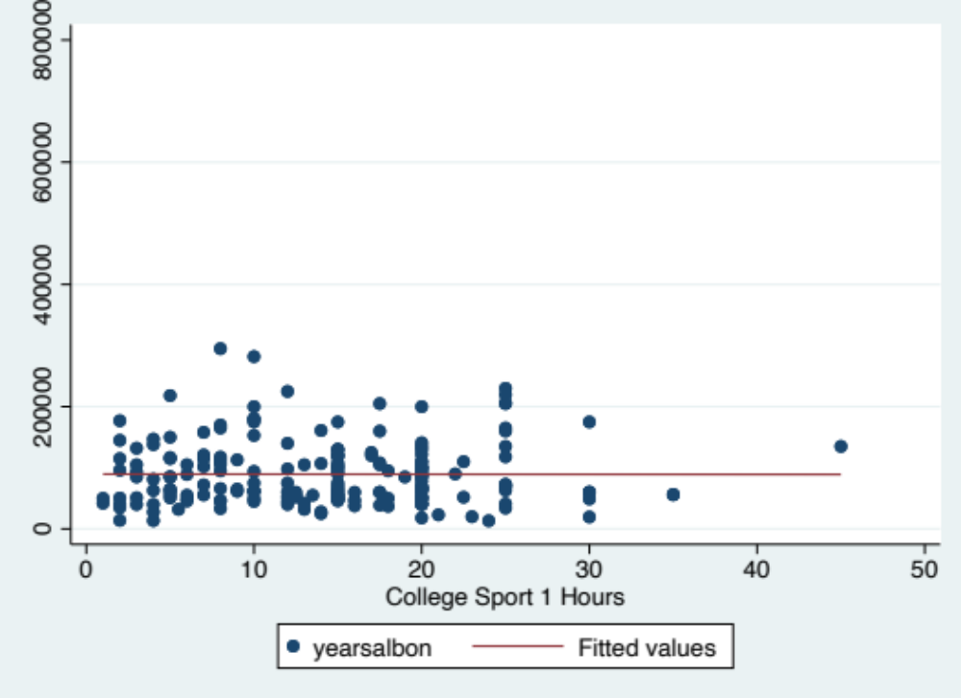

- . graph export "/Users/lizziehealy/Desktop/Econ 304/Final Project/linlin hrs1.pdf", as( > pdf) name("Graph")
file /Users/lizziehealy/Desktop/Econ 304/Final Project/linlin hrs1.pdf saved as PDF format
- . twoway scatter resid yhat
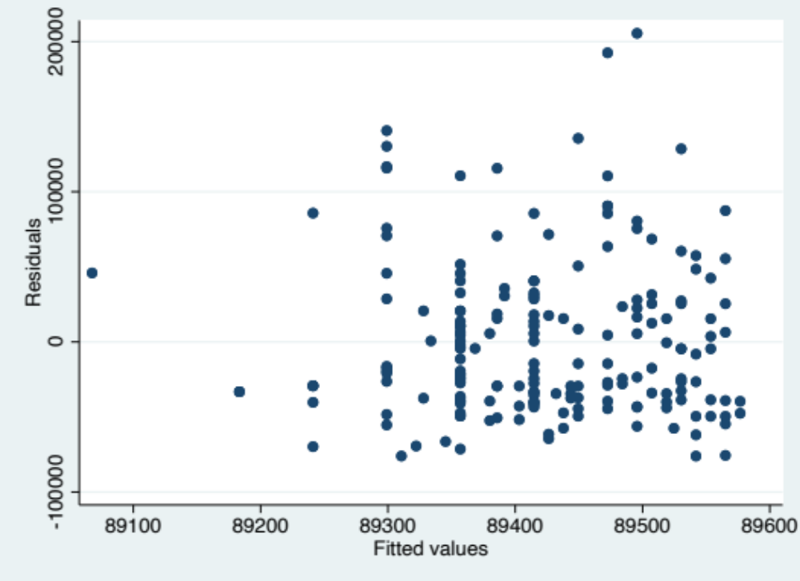

- . graph export "/Users/lizziehealy/Desktop/Econ 304/Final Project/linlin hrs resid1.pdf > ", as(pdf) name("Graph")
file /Users/lizziehealy/Desktop/Econ 304/Final Project/linlin hrs resid1.pdf saved as PDF format
- . sum yearsalbon colsport1_hrs
Variable | Obs Mean Std. dev. Min Max
yearsalbon | 527 88066.17 61235.19 9000 672300
colsport1_~s | 259 13.98842 8.114691 .75 45
- . generate lnyearsalbon=ln(yearsalbon)
(161 missing values generated)
- . regress lnyearsalbon colsport1_hrs, robust
Linear regression Number of obs = 195
F(1, 193) = 0.00
Prob > F = 0.9980
R-squared = 0.0000 Root MSE = .59116
 | Robust
lnyearsalbon | Coefficient std. err. t P>|t| [95% conf. interval]
colsport1_hrs | -.0000144 .005804 -0.00 0.998 -.0114618 .0114331
_cons | 11.23741 .0939709 119.58 0.000 11.05207 11.42275
- . predict residloglin, resid
  - missing values generated)
- . predict yhatloglin
(option xb assumed; fitted values)
(429 missing values generated)
- . graph twoway (scatter lnyearsalbon colsport1_hrs) (lfit lnyearsalbon colsport1_hrs)
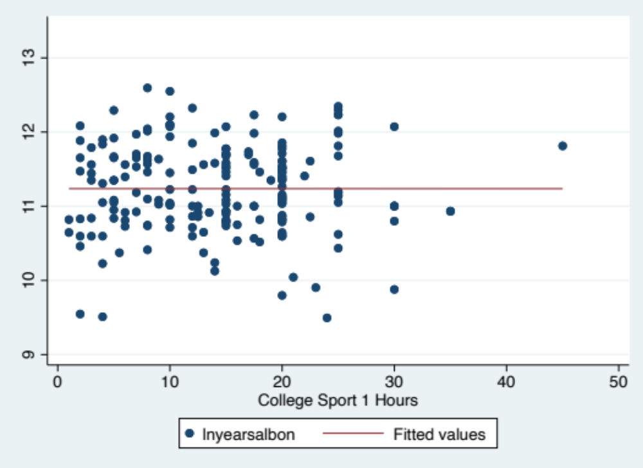
- . graph export "/Users/lizziehealy/Desktop/Econ 304/Final Project/loglin hrs1.pdf", as( > pdf) name("Graph")
file /Users/lizziehealy/Desktop/Econ 304/Final Project/loglin hrs1.pdf saved as PDF format
- . twoway scatter residloglin yhatloglin
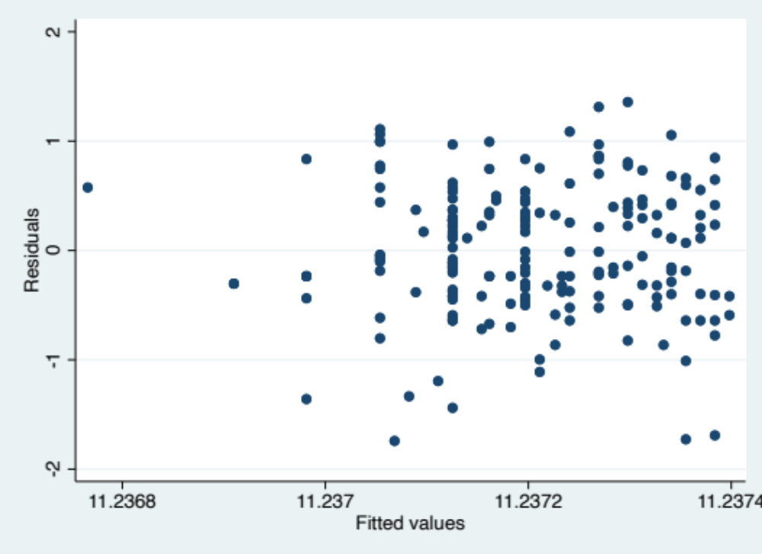
- . graph export "/Users/lizziehealy/Desktop/Econ 304/Final Project/loglin hrs resid1.pdf > ", as(pdf) name("Graph")
file /Users/lizziehealy/Desktop/Econ 304/Final Project/loglin hrs resid1.pdf saved as PDF format
- . generate lncolsport1_hrs=ln(colsport1_hrs) (429 missing values generated)
- . regress yearsalbon lncolsport1_hrs, robust
Linear regression Number of obs = 195
F(1, 193) = 0.13
Prob > F = 0.7220
R-squared = 0.0006
Root MSE = 52187
 | Robust
yearsalbon | Coefficient std. err. t P>|t| [95% conf. interval]
lncolsport1_hrs | 1736.493 4872.995 0.36 0.722 -7874.669 11347.65
_cons | 85153.03 12544.03 6.79 0.000 60412.04 109894
- . predict residlinlog, resid
  - missing values generated)
- . predict yhatlinlog
(option xb assumed; fitted values)
(429 missing values generated)
- . graph twoway (scatter yearsalbon lncolsport1_hrs) (lfit yearsalbon lncolsport1_hrs)
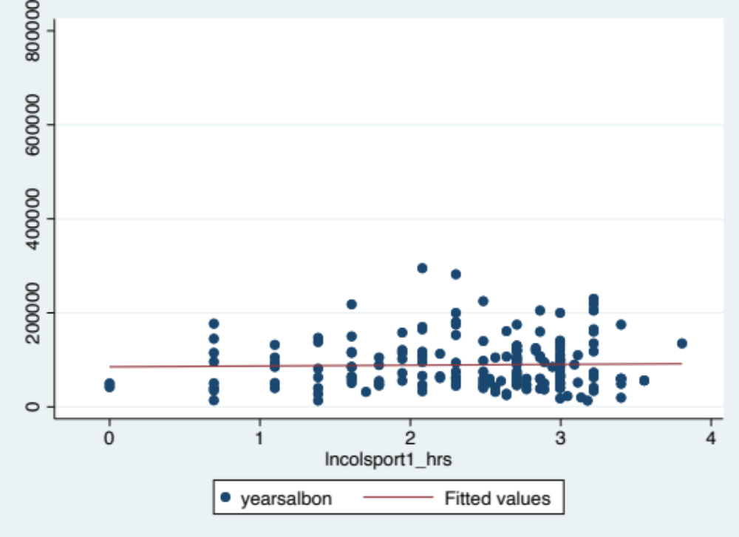
- . graph export "/Users/lizziehealy/Desktop/Econ 304/Final Project/linlog hrs1.pdf", as( > pdf) name("Graph")
file /Users/lizziehealy/Desktop/Econ 304/Final Project/linlog hrs1.pdf saved as PDF format
- . twoway scatter residlinlog yhatlinlog
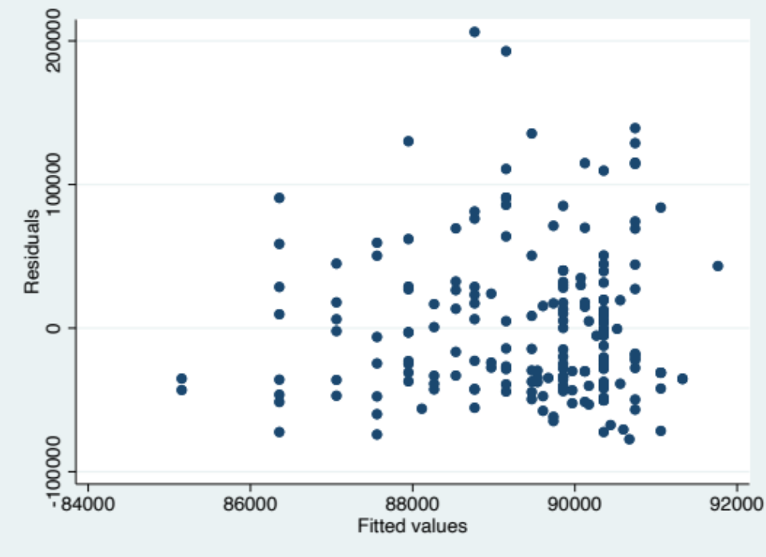

- . graph export "/Users/lizziehealy/Desktop/Econ 304/Final Project/linlog hrs resid1.pdf > ", as(pdf) name("Graph")
file /Users/lizziehealy/Desktop/Econ 304/Final Project/linlog hrs resid1.pdf saved as PDF format
- . regress lnyearsalbon lncolsport1_hrs, robust
Linear regression Number of obs = 195
F(1, 193) = 0.25
Prob > F = 0.6184
R-squared = 0.0016
Root MSE = .5907
 | Robust
lnyearsalbon | Coefficient std. err. t P>|t| [95% conf. interval]
lncolsport1_hrs | .0315842 .0632973 0.50 0.618 -.0932592 .1564275
_cons | 11.15957 .1633923 68.30 0.000 10.83731 11.48183
- . predict residloglog, resid
  - missing values generated)
- . predict yhatloglog
(option xb assumed; fitted values)
(429 missing values generated)
- . graph twoway (scatter lnyearsalbon lncolsport1_hrs) (lfit lnyearsalbon lncolsport1_hr > s)
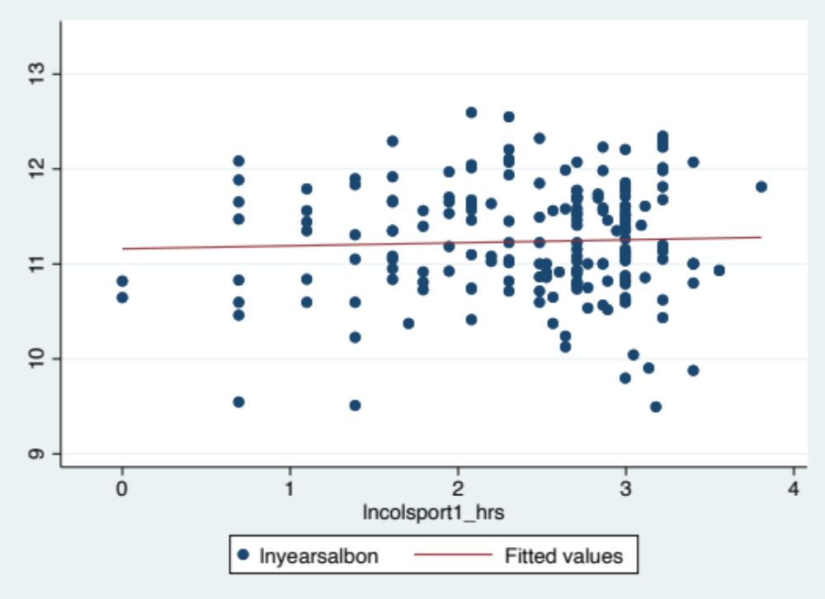
- . graph export "/Users/lizziehealy/Desktop/Econ 304/Final Project/loglog hrs1.pdf", as( > pdf) name("Graph")
file /Users/lizziehealy/Desktop/Econ 304/Final Project/loglog hrs1.pdf saved as PDF format
- . twoway scatter residloglog yhatloglog
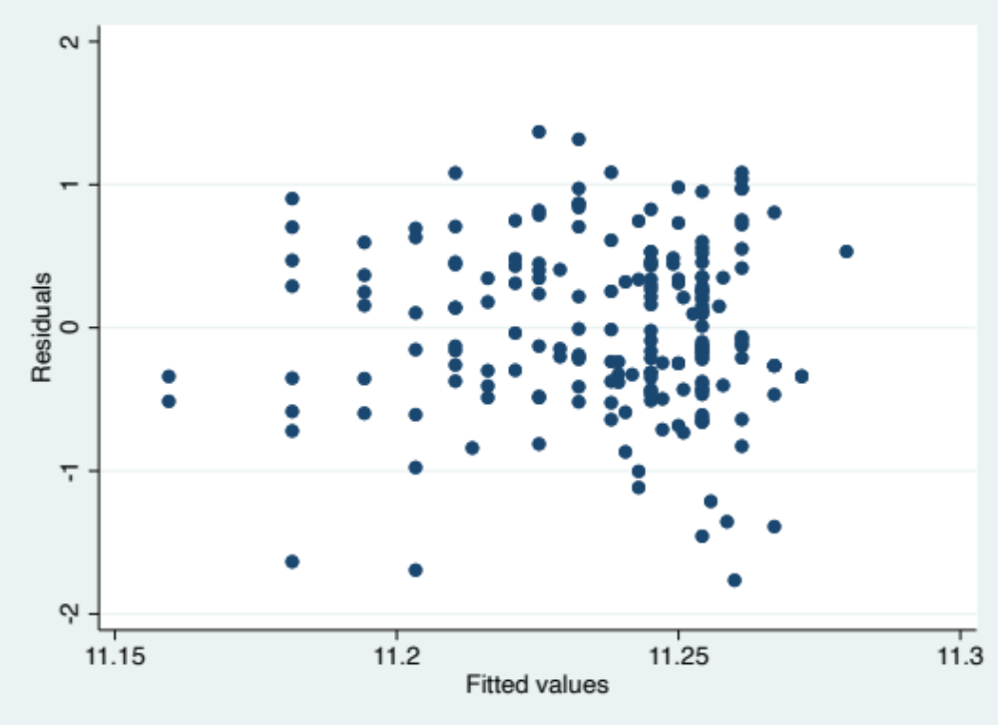
- . graph export "/Users/lizziehealy/Desktop/Econ 304/Final Project/loglog hrs resid1.pdf > ", as(pdf) name("Graph")
file /Users/lizziehealy/Desktop/Econ 304/Final Project/loglog hrs resid1.pdf saved as PDF format
- . generate female=0
- . replace female=1 if gender=="Female"
(459 real changes made)
- . replace female=. if gender==""
(1 real change made, 1 to missing)
- . tab female
female | Freq. Percent Cum.
0 | 228 33.19 33.19
1 | 459 66.81 100.00
Total | 687 100.00
- .
- . tab colsport1_level, nolabel
College  Sport 1  Level | Freq. Percent Cum.
1 | 122 47.29 47.29
2 | 1 0.39 47.67
3 | 134 51.94 99.61
47 | 1 0.39 100.00
Total | 258 100.00
- . generate varsity=0
- . replace varsity=1 if colsport1_level==1
(122 real changes made)
- . generate otherlevel=0
- . replace otherlevel=1 if colsport1_level==2 (1 real change made)
- . replace otherlevel=1 if colsport1_level==3 (134 real changes made)
- . replace otherlevel=1 if colsport1_level==47
(1 real change made)
- . tab varsity
varsity | Freq. Percent Cum.
0 | 566 82.27 82.27
1 | 122 17.73 100.00
Total | 688 100.00
- . tab otherlevel
otherlevel | Freq. Percent Cum.
0 | 552 80.23 80.23
1 | 136 19.77 100.00
Total | 688 100.00
- . generate femalevarsity=female*varsity
(1 missing value generated)
- . generate femaleotherlevel=female*otherlevel
(1 missing value generated)
- .
- .
- . regress lnyearsalbon lncolsport1_hrs varsity otherlevel, robust
Linear regression Number of obs = 195
F(3, 191) = 1.49
Prob > F = 0.2184
R-squared = 0.0185
Root MSE = .58872
 | Robust
lnyearsalbon | Coefficient std. err. t P>|t| [95% conf. interval]
lncolsport1_hrs | .0688938 .0789324 0.87 0.384 -.0867973 .2245849
varsity | -.5126336 .2613311 -1.96 0.051 -1.028099 .002832
otherlevel | -.415152 .2658718 -1.56 0.120 -.9395741 .10927
_cons | 11.52049 .332084 34.69 0.000 10.86546 12.17551
- . xi: regress lnyearsalbon lncolsport1_hrs varsity otherlevel, cluster(id)
Linear regression Number of obs = 195
F(3, 194) = 1.49
Prob > F = 0.2183
R-squared = 0.0185
Root MSE = .58872
(Std. err. adjusted for 195 clusters in id)
 | Robust
lnyearsalbon | Coefficient std. err. t P>|t| [95% conf. interval]
lncolsport1_hrs | .0688938 .0789324 0.87 0.384 -.0867819 .2245696
varsity | -.5126336 .2613311 -1.96 0.051 -1.028048 .0027812
otherlevel | -.415152 .2658718 -1.56 0.120 -.9395224 .1092183
_cons | 11.52049 .332084 34.69 0.000 10.86553 12.17544
- . regress lnyearsalbon lncolsport1_hrs varsity otherlevel, cluster(id)
Linear regression Number of obs = 195
F(3, 194) = 1.49
Prob > F = 0.2183
R-squared = 0.0185
Root MSE = .58872
(Std. err. adjusted for 195 clusters in id)
 | Robust
lnyearsalbon | Coefficient std. err. t P>|t| [95% conf. interval]
lncolsport1_hrs | .0688938 .0789324 0.87 0.384 -.0867819 .2245696
varsity | -.5126336 .2613311 -1.96 0.051 -1.028048 .0027812
otherlevel | -.415152 .2658718 -1.56 0.120 -.9395224 .1092183
_cons | 11.52049 .332084 34.69 0.000 10.86553 12.17544
- . test (varsity=otherlevel)
( 1) varsity - otherlevel = 0
F( 1, 194) = 0.84
Prob > F = 0.3600
- . outreg2 using "/Users/lizziehealy/Desktop/FinalTable.doc", word keep (varsity otherle > vel female femalevarsity femaleotherlevel lncolsport1_hrs) ti (Table 1 Does Participa
> tion in College Sports Impact Salary?) nolabel replace
/Users/lizziehealy/Desktop/FinalTable.doc dir : seeout
- . xi: regress lnyearsalbon lncolsport1_hrs varsity otherlevel female femalevarsity fema
> leotherlevel, cluster(id)
Linear regression Number of obs = 195
F(6, 194) = 70.47
Prob > F = 0.0000
R-squared = 0.1208
Root MSE = .56163
(Std. err. adjusted for 195 clusters in id)
 | Robust
lnyearsalbon | Coefficient std. err. t P>|t| [95% conf. interval]
lncolsport1_hrs | .0213602 .0747607 0.29 0.775 -.126088 .1688084
varsity | -.6866289 .1038924 -6.61 0.000 -.8915325 -.4817253
otherlevel | -.5841474 .0914467 -6.39 0.000 -.7645047 -.4037901
female | -.7749378 .3271457 -2.37 0.019 -1.420157 -.1297189
femalevarsity | .458551 .3494914 1.31 0.191 -.2307396 1.147842
femaleotherlevel | .351842 .3479206 1.01 0.313 -.3343505 1.038034
_cons | 12.03311 .1877684 64.08 0.000 11.66278 12.40344

- . test (varsity=otherlevel)
( 1) varsity - otherlevel = 0
F( 1, 194) = 0.51
Prob > F = 0.4754
- . test (femalevarsity=femaleotherlevel)
( 1) femalevarsity - femaleotherlevel = 0
F( 1, 194) = 0.40
Prob > F = 0.5254
- . outreg2 using "/Users/lizziehealy/Desktop/FinalTable.doc", word keep (varsity otherle > vel female femalevarsity femaleotherlevel lncolsport1_hrs) ti (Table 1 Does Participa
> tion in College Sports Impact Salary?) nolabel append
/Users/lizziehealy/Desktop/FinalTable.doc dir : seeout
- . xi: regress lnyearsalbon lncolsport1_hrs varsity otherlevel female femalevarsity fema
> leotherlevel i.sector i.yearofpgsurvey i.mthswrkp, cluster(id)
i.sector _Isector_1-7 (_Isector_1 for sec~r==Family Business omitted)
i.yearofpgsur~y _Iyearofpgs_2012-2019(naturally coded; _Iyearofpgs_2012 omitted)
i.mthswrkp _Imthswrkp_1-84 (_Imthswrkp_1 for mthswrkp==0 omitted) note: _Isector_3 omitted because of collinearity. note: _Imthswrkp_2 omitted because of collinearity. note: _Imthswrkp_5 omitted because of collinearity. note: _Imthswrkp_8 omitted because of collinearity. note: _Imthswrkp_22 omitted because of collinearity. note: _Imthswrkp_33 omitted because of collinearity. note: _Imthswrkp_37 omitted because of collinearity. note: _Imthswrkp_38 omitted because of collinearity. note: _Imthswrkp_40 omitted because of collinearity. note: _Imthswrkp_41 omitted because of collinearity. note: _Imthswrkp_44 omitted because of collinearity. note: _Imthswrkp_49 omitted because of collinearity. note: _Imthswrkp_55 omitted because of collinearity. note: _Imthswrkp_60 omitted because of collinearity. note: _Imthswrkp_63 omitted because of collinearity. note: _Imthswrkp_64 omitted because of collinearity. note: _Imthswrkp_66 omitted because of collinearity. note: _Imthswrkp_67 omitted because of collinearity. note: _Imthswrkp_68 omitted because of collinearity. note: _Imthswrkp_70 omitted because of collinearity. note: _Imthswrkp_73 omitted because of collinearity. note: _Imthswrkp_75 omitted because of collinearity. note: _Imthswrkp_76 omitted because of collinearity. note: _Imthswrkp_78 omitted because of collinearity. note: _Imthswrkp_80 omitted because of collinearity. note: _Imthswrkp_83 omitted because of collinearity.
Linear regression Number of obs = 181 F(51, 180) = .
Prob > F = .
R-squared = 0.6005
Root MSE = .48045
(Std. err. adjusted for 181 clusters in id)
 | Robust
lnyearsalbon | Coefficient std. err. t P>|t| [95% conf. interval]
lncolsport1_hrs | .0906794 .1175883 0.77 0.442 -.1413494 .3227082
varsity | -.6484858 .2268264 -2.86 0.005 -1.096067 -.200905
otherlevel | -.6454205 .2297434 -2.81 0.006 -1.098757 -.1920837
female | -.8224211 .211905 -3.88 0.000 -1.240559 -.4042836
femalevarsity | .621529 .2509947 2.48 0.014 .1262584 1.1168
femaleotherlevel | .5660573 .2515878 2.25 0.026 .0696166 1.062498
_Isector_2 | -.0084792 .3556652 -0.02 0.981 -.7102888 .6933303
_Isector_3 | 0 (omitted)
_Isector_4 | -.0391609 .3099655 -0.13 0.900 -.6507944 .5724726
_Isector_5 | .3190773 .279965 1.14 0.256 -.2333582 .8715128
_Isector_6 | -.0142682 .3750698 -0.04 0.970 -.7543675 .725831
_Isector_7 | -.0919148 .3413969 -0.27 0.788 -.7655697 .58174
_Iyearofpgs_2013 | -.5840104 .2162228 -2.70 0.008 -1.010668 -.1573529
_Iyearofpgs_2014 | -.6478465 .302297 -2.14 0.033 -1.244348 -.0513447
_Iyearofpgs_2015 | -1.057795 .3773587 -2.80 0.006 -1.80241 -.3131787
_Iyearofpgs_2016 | -.0937058 .2701061 -0.35 0.729 -.6266874 .4392759
_Iyearofpgs_2017 | -.1176114 .2374694 -0.50 0.621 -.5861933 .3509704
_Iyearofpgs_2018 | -.1059757 .2315716 -0.46 0.648 -.5629199 .3509685
_Iyearofpgs_2019 | .0568514 .2417256 0.24 0.814 -.420129 .5338318
_Imthswrkp_2 | 0 (omitted)
_Imthswrkp_3 | .1767398 .2969791 0.60 0.553 -.4092685 .7627481
_Imthswrkp_4 | .0714854 .362269 0.20 0.844 -.6433549 .7863258
_Imthswrkp_5 | 0 (omitted)
_Imthswrkp_6 | .774512 .5217274 1.48 0.139 -.2549765 1.804
_Imthswrkp_7 | .30125 .3516023 0.86 0.393 -.3925426 .9950426
_Imthswrkp_8 | 0 (omitted)
_Imthswrkp_9 | -.1971561 .4145901 -0.48 0.635 -1.015238 .6209259
_Imthswrkp_10 | .3604476 .2338595 1.54 0.125 -.101011 .8219063
_Imthswrkp_11 | .2373507 .331275 0.72 0.475 -.4163312 .8910327
_Imthswrkp_12 | -.0220903 .2915738 -0.08 0.940 -.5974327 .5532521
_Imthswrkp_13 | .0637257 .304265 0.21 0.834 -.5366593 .6641107
_Imthswrkp_14 | .2276352 .3109225 0.73 0.465 -.3858867 .8411571
_Imthswrkp_15 | .2474939 .3514385 0.70 0.482 -.4459754 .9409631
_Imthswrkp_16 | .105568 .3600533 0.29 0.770 -.6049003 .8160363
_Imthswrkp_17 | .1570821 .2870867 0.55 0.585 -.4094063 .7235705
_Imthswrkp_18 | .0247831 .299219 0.08 0.934 -.5656451 .6152112
_Imthswrkp_19 | .3475184 .3023822 1.15 0.252 -.2491515 .9441883
_Imthswrkp_20 | .3501342 .3024355 1.16 0.249 -.246641 .9469093
_Imthswrkp_21 | .6166593 .3690368 1.67 0.096 -.1115356 1.344854
_Imthswrkp_22 | 0 (omitted)
_Imthswrkp_23 | .3238577 .3050207 1.06 0.290 -.2780186 .925734
_Imthswrkp_24 | .1996828 .3475295 0.57 0.566 -.486073 .8854387
_Imthswrkp_25 | .3854021 .3899507 0.99 0.324 -.3840606 1.154865
_Imthswrkp_26 -.4730392 .3913076 -1.21 0.228 -1.245179 .299101
_Imthswrkp_27 .695128 .3230761 2.15 0.033 .0576243 1.332632
_Imthswrkp_28 .686664 .3702441 1.85 0.065 -.0439131 1.417241
_Imthswrkp_29 -.4747889 .2481872 -1.91 0.057 -.9645195 .0149417
_Imthswrkp_30 .3454016 .336809 1.03 0.306 -.3192003 1.010004
_Imthswrkp_31 -.1148683 .2654482 -0.43 0.666 -.6386588 .4089223
_Imthswrkp_32 .4948363 .3872731 1.28 0.203 -.269343 1.259016
_Imthswrkp_33 0 (omitted)
_Imthswrkp_34 .2027588 .3586015 0.57 0.572 -.5048447 .9103623
_Imthswrkp_35 -.115165 .4747853 -0.24 0.809 -1.052026 .821696
_Imthswrkp_36 .5574381 .3527164 1.58 0.116 -.1385527 1.253429
_Imthswrkp_37 0 (omitted)
_Imthswrkp_38 0 (omitted)
_Imthswrkp_39 .6497888 .3680985 1.77 0.079 -.0765546 1.376132
_Imthswrkp_40 0 (omitted)
_Imthswrkp_41 0 (omitted)
_Imthswrkp_42 .2704642 .3081875 0.88 0.381 -.3376609 .8785893
_Imthswrkp_43 .2440623 .3410049 0.72 0.475 -.4288191 .9169437
_Imthswrkp_44 0 (omitted)
_Imthswrkp_45 -.1647279 .36891 -0.45 0.656 -.8926724 .5632167
_Imthswrkp_46 .757995 .2940338 2.58 0.011 .1777984 1.338192
_Imthswrkp_47 -1.035358 .3161703 -3.27 0.001 -1.659235 -.4114812
_Imthswrkp_48 .4462706 .3904603 1.14 0.255 -.3241978 1.216739
_Imthswrkp_49 0 (omitted)
_Imthswrkp_50 .6372992 .3874069 1.65 0.102 -.127144 1.401743
_Imthswrkp_51 .8391668 .328209 2.56 0.011 .1915346 1.486799
_Imthswrkp_52 .9261209 .2846925 3.25 0.001 .3643569 1.487885
_Imthswrkp_53 .5539458 .2954902 1.87 0.062 -.0291246 1.137016
_Imthswrkp_54 .434581 .3341871 1.30 0.195 -.2248472 1.094009
_Imthswrkp_55 0 (omitted)
_Imthswrkp_56 -.368572 .3436363 -1.07 0.285 -1.046646 .3095017
_Imthswrkp_57 -.0979352 .2166883 -0.45 0.652 -.5255112 .3296409
_Imthswrkp_58 .7676314 .276868 2.77 0.006 .221307 1.313956
_Imthswrkp_59 .4008792 .3180321 1.26 0.209 -.2266716 1.02843
_Imthswrkp_60 0 (omitted)
_Imthswrkp_61 -.0061411 .4872826 -0.01 0.990 -.9676622 .9553799
_Imthswrkp_62 -.0337182 .3193093 -0.11 0.916 -.6637891 .5963527
_Imthswrkp_63 0 (omitted)
_Imthswrkp_64 0 (omitted)
_Imthswrkp_65 .5818649 .3134817 1.86 0.065 -.0367069 1.200437
_Imthswrkp_66 0 (omitted)
_Imthswrkp_67 0 (omitted)
_Imthswrkp_68 0 (omitted)
_Imthswrkp_69 .1280076 .3251214 0.39 0.694 -.5135321 .7695472
_Imthswrkp_70 0 (omitted)
_Imthswrkp_71 .872292 .3857575 2.26 0.025 .1111034 1.633481
_Imthswrkp_72 .2898733 .3071351 0.94 0.347 -.3161752 .8959218
_Imthswrkp_73 0 (omitted)
_Imthswrkp_74 .7315393 .3661301 2.00 0.047 .00908 1.453999
_Imthswrkp_75 0 (omitted)
_Imthswrkp_76 0 (omitted)
_Imthswrkp_77 -.1988685 .3411922 -0.58 0.561 -.8721195 .4743825
_Imthswrkp_78 0 (omitted)
_Imthswrkp_79 .108713 .304577 0.36 0.722 -.4922878 .7097138
_Imthswrkp_80 | 0 (omitted)
_Imthswrkp_81 | .3376056 .5897441 0.57 0.568 -.8260955 1.501307
_Imthswrkp_82 | .4474656 .279717 1.60 0.111 -.1044806 .9994118
_Imthswrkp_83 | 0 (omitted)
_Imthswrkp_84 | .7566553 .3695675 2.05 0.042 .0274132 1.485897
_cons | 11.44814 .4180923 27.38 0.000 10.62315 12.27314
- . xi: testparm i.yearofpgsurvey
i.yearofpgsur~y _Iyearofpgs_2012-2019(naturally coded; _Iyearofpgs_2012 omitted)
( 1) _Iyearofpgs_2013 = 0
( 2) _Iyearofpgs_2014 = 0
( 3) _Iyearofpgs_2015 = 0
( 4) _Iyearofpgs_2016 = 0
( 5) _Iyearofpgs_2017 = 0
( 6) _Iyearofpgs_2018 = 0
( 7) _Iyearofpgs_2019 = 0
F( 7, 180) = 4.98
Prob > F = 0.0000
- . xi: testparm i.mthswrkp
i.mthswrkp _Imthswrkp_1-84 (_Imthswrkp_1 for mthswrkp==0 omitted)
( 1) _Imthswrkp_3 = 0
( 2) _Imthswrkp_4 = 0
( 3) _Imthswrkp_6 = 0
( 4) _Imthswrkp_7 = 0
( 5) _Imthswrkp_9 = 0
( 6) _Imthswrkp_10 = 0
( 7) _Imthswrkp_11 = 0
( 8) _Imthswrkp_12 = 0
( 9) _Imthswrkp_13 = 0
(10) _Imthswrkp_14 = 0 (11) _Imthswrkp_15 = 0 (12) _Imthswrkp_16 = 0 (13) _Imthswrkp_17 = 0 (14) _Imthswrkp_18 = 0 (15) _Imthswrkp_19 = 0 (16) _Imthswrkp_20 = 0 (17) _Imthswrkp_21 = 0 (18) _Imthswrkp_23 = 0 (19) _Imthswrkp_24 = 0 (20) _Imthswrkp_25 = 0 (21) _Imthswrkp_26 = 0 (22) _Imthswrkp_27 = 0 (23) _Imthswrkp_28 = 0 (24) _Imthswrkp_29 = 0 (25) _Imthswrkp_30 = 0 (26) _Imthswrkp_31 = 0 (27) _Imthswrkp_32 = 0 (28) _Imthswrkp_34 = 0
  - _Imthswrkp_35 = 0
  - _Imthswrkp_36 = 0 (31) _Imthswrkp_39 = 0 (32) _Imthswrkp_42 = 0 (33) _Imthswrkp_43 = 0 (34) _Imthswrkp_45 = 0 (35) _Imthswrkp_46 = 0 (36) _Imthswrkp_47 = 0 (37) _Imthswrkp_48 = 0 (38) _Imthswrkp_50 = 0 (39) _Imthswrkp_51 = 0 (40) _Imthswrkp_52 = 0 (41) _Imthswrkp_53 = 0 (42) _Imthswrkp_54 = 0 (43) _Imthswrkp_56 = 0 (44) _Imthswrkp_57 = 0 (45) _Imthswrkp_58 = 0 (46) _Imthswrkp_59 = 0 (47) _Imthswrkp_61 = 0 (48) _Imthswrkp_62 = 0 (49) _Imthswrkp_65 = 0 (50) _Imthswrkp_69 = 0 (51) _Imthswrkp_71 = 0 (52) _Imthswrkp_72 = 0 (53) _Imthswrkp_74 = 0 (54) _Imthswrkp_77 = 0 (55) _Imthswrkp_79 = 0 (56) _Imthswrkp_81 = 0 (57) _Imthswrkp_82 = 0
(58) _Imthswrkp_84 = 0 Constraint 1 dropped
Constraint 9 dropped
Constraint 16 dropped
Constraint 18 dropped
Constraint 24 dropped
Constraint 36 dropped
Constraint 39 dropped
Constraint 40 dropped
Constraint 43 dropped
Constraint 45 dropped
Constraint 52 dropped
Constraint 54 dropped
Constraint 58 dropped
F( 45, 180) = 4.23
Prob > F = 0.0000
- . xi: testparm i.sector
i.sector _Isector_1-7 (_Isector_1 for sec~r==Family Business omitted)
( 1) _Isector_2 = 0 ( 2) _Isector_4 = 0
( 3) _Isector_5 = 0
( 4) _Isector_6 = 0
( 5) _Isector_7 = 0
F( 5, 180) = 3.45
Prob > F = 0.0053
- . test (femalevarsity=femaleotherlevel)
( 1) femalevarsity - femaleotherlevel = 0
F( 1, 180) = 0.07
Prob > F = 0.7920
- . outreg2 using "/Users/lizziehealy/Desktop/FinalTable.doc", word keep (varsity otherle > vel female femalevarsity femaleotherlevel lncolsport1_hrs) ti (Table 1 Does Participa
> tion in College Sports Impact Salary?) nolabel append
/Users/lizziehealy/Desktop/FinalTable.doc dir : seeout
- . xi: regress lnyearsalbon lncolsport1_hrs varsity otherlevel female femalevarsity fema
> leotherlevel i.sector i.yearofpgsurvey i.mthswrkp i.colsport1, cluster(id)
i.sector _Isector_1-7 (_Isector_1 for sec~r==Family Business omitted)
i.yearofpgsur~y _Iyearofpgs_2012-2019(naturally coded; _Iyearofpgs_2012 omitted)
i.mthswrkp _Imthswrkp_1-84 (_Imthswrkp_1 for mthswrkp==0 omitted)
i.colsport1 _Icolsport1_1-60 (naturally coded; _Icolsport1_1 omitted) note: _Isector_3 omitted because of collinearity. note: _Imthswrkp_2 omitted because of collinearity. note: _Imthswrkp_5 omitted because of collinearity. note: _Imthswrkp_8 omitted because of collinearity. note: _Imthswrkp_22 omitted because of collinearity. note: _Imthswrkp_33 omitted because of collinearity. note: _Imthswrkp_37 omitted because of collinearity. note: _Imthswrkp_40 omitted because of collinearity. note: _Imthswrkp_41 omitted because of collinearity. note: _Imthswrkp_44 omitted because of collinearity. note: _Imthswrkp_49 omitted because of collinearity. note: _Imthswrkp_55 omitted because of collinearity. note: _Imthswrkp_57 omitted because of collinearity. note: _Imthswrkp_60 omitted because of collinearity. note: _Imthswrkp_63 omitted because of collinearity. note: _Imthswrkp_64 omitted because of collinearity. note: _Imthswrkp_66 omitted because of collinearity. note: _Imthswrkp_67 omitted because of collinearity. note: _Imthswrkp_68 omitted because of collinearity. note: _Imthswrkp_70 omitted because of collinearity. note: _Imthswrkp_73 omitted because of collinearity. note: _Imthswrkp_75 omitted because of collinearity. note: _Imthswrkp_76 omitted because of collinearity. note: _Imthswrkp_78 omitted because of collinearity. note: _Imthswrkp_80 omitted because of collinearity. note: _Imthswrkp_83 omitted because of collinearity. note: _Icolsport1_13 omitted because of collinearity. note: _Icolsport1_16 omitted because of collinearity. note: _Icolsport1_20 omitted because of collinearity. note: _Icolsport1_28 omitted because of collinearity. note: _Icolsport1_42 omitted because of collinearity.
note: _Icolsport1_43 omitted because of collinearity. note: _Icolsport1_47 omitted because of collinearity. note: _Icolsport1_51 omitted because of collinearity.
Linear regression Number of obs = 181 F(69, 180) = .
Prob > F = .
R-squared = 0.7073
Root MSE = .4843
(Std. err. adjusted for 181 clusters in id)
 | Robust
lnyearsalbon | Coefficient std. err. t P>|t| [95% conf. interval]
lncolsport1_hrs | .0751602 .1576986 0.48 0.634 -.2360155 .386336
varsity | -.731091 .3845277 -1.90 0.059 -1.489853 .0276709
otherlevel | -.9556705 .4214718 -2.27 0.025 -1.787332 -.1240093
female | -.7565862 .27557 -2.75 0.007 -1.300349 -.2128231
femalevarsity | .6065458 .3496227 1.73 0.084 -.0833405 1.296432
femaleotherlevel | .5124818 .3821844 1.34 0.182 -.2416563 1.26662
_Isector_2 | .1998779 .468425 0.43 0.670 -.7244328 1.124189
_Isector_3 | 0 (omitted)
_Isector_4 | .157919 .4155194 0.38 0.704 -.6619966 .9778345
_Isector_5 | .4777605 .4084633 1.17 0.244 -.328232 1.283753
_Isector_6 | .1483667 .50378 0.29 0.769 -.8457075 1.142441
_Isector_7 | -.0294335 .4768826 -0.06 0.951 -.9704329 .911566
_Iyearofpgs_2013 | -.6352693 .3897495 -1.63 0.105 -1.404335 .1337965
_Iyearofpgs_2014 | -.8628543 .4814816 -1.79 0.075 -1.812929 .08722
_Iyearofpgs_2015 | -1.193892 .5095397 -2.34 0.020 -2.199332 -.1884526
_Iyearofpgs_2016 | -.1277528 .4449874 -0.29 0.774 -1.005816 .75031
_Iyearofpgs_2017 | -.1121436 .4412292 -0.25 0.800 -.9827907 .7585034
_Iyearofpgs_2018 | -.2710704 .3853011 -0.70 0.483 -1.031358 .4892176
_Iyearofpgs_2019 | -.1082843 .3986526 -0.27 0.786 -.8949179 .6783493
_Imthswrkp_2 | 0 (omitted)
_Imthswrkp_3 | -.5678453 .957814 -0.59 0.554 -2.457833 1.322143
_Imthswrkp_4 | -.1103523 .6133132 -0.18 0.857 -1.320561 1.099856
_Imthswrkp_5 | 0 (omitted)
_Imthswrkp_6 | .5439906 .7098552 0.77 0.444 -.8567176 1.944699
_Imthswrkp_7 | .2064996 .5324686 0.39 0.699 -.8441839 1.257183
_Imthswrkp_8 | 0 (omitted)
_Imthswrkp_9 | -.1484985 .6449972 -0.23 0.818 -1.421227 1.12423
_Imthswrkp_10 | -.0716794 .5199886 -0.14 0.891 -1.097737 .9543781
_Imthswrkp_11 | .1322739 .543137 0.24 0.808 -.9394607 1.204009
_Imthswrkp_12 | -.436448 .519342 -0.84 0.402 -1.46123 .5883336
_Imthswrkp_13 | .2272829 .6112166 0.37 0.710 -.9787885 1.433354
_Imthswrkp_14 | .0202418 .4703205 0.04 0.966 -.9078092 .9482928
_Imthswrkp_15 | -.024649 .6137948 -0.04 0.968 -1.235808 1.18651
_Imthswrkp_16 | -.1628936 .519062 -0.31 0.754 -1.187123 .8613355
_Imthswrkp_17 | -.6327928 .5920059 -1.07 0.287 -1.800957 .5353715
_Imthswrkp_18 | -.3142148 .5934568 -0.53 0.597 -1.485242 .8568125
_Imthswrkp_19 | .2041621 .3524537 0.58 0.563 -.4913105 .8996346
_Imthswrkp_20 | .1529427 .6577508 0.23 0.816 -1.144951 1.450837
_Imthswrkp_21 | .5135275 .5502401 0.93 0.352 -.5722232 1.599278
_Imthswrkp_22 0 (omitted)
_Imthswrkp_23 -.1620145 .6445881 -0.25 0.802 -1.433936 1.109907
_Imthswrkp_24 -.1782322 .6132282 -0.29 0.772 -1.388273 1.031809
_Imthswrkp_25 .1956531 .6163157 0.32 0.751 -1.02048 1.411786
_Imthswrkp_26 -.8247288 .5107625 -1.61 0.108 -1.832581 .1831234
_Imthswrkp_27 .6002674 .6297278 0.95 0.342 -.642331 1.842866
_Imthswrkp_28 .7664798 .5356975 1.43 0.154 -.2905751 1.823535
_Imthswrkp_29 -.9719189 .6004673 -1.62 0.107 -2.156779 .2129416
_Imthswrkp_30 .1346028 .5305036 0.25 0.800 -.9122032 1.181409
_Imthswrkp_31 -.3097568 .5084109 -0.61 0.543 -1.312969 .6934553
_Imthswrkp_32 .3199595 .5590627 0.57 0.568 -.7832003 1.423119
_Imthswrkp_33 0 (omitted)
_Imthswrkp_34 -.0414784 .5136931 -0.08 0.936 -1.055113 .9721567
_Imthswrkp_35 -.3871695 .5608816 -0.69 0.491 -1.493918 .7195795
_Imthswrkp_36 .2276115 .5708782 0.40 0.691 -.8988629 1.354086
_Imthswrkp_37 0 (omitted)
_Imthswrkp_38 .1566735 .2730352 0.57 0.567 -.3820879 .6954349
_Imthswrkp_39 .38465 .7220175 0.53 0.595 -1.040057 1.809357
_Imthswrkp_40 0 (omitted)
_Imthswrkp_41 0 (omitted)
_Imthswrkp_42 -.0324862 .5545813 -0.06 0.953 -1.126803 1.061831
_Imthswrkp_43 .1692967 .6393468 0.26 0.791 -1.092282 1.430875
_Imthswrkp_44 0 (omitted)
_Imthswrkp_45 -.2528157 .5507023 -0.46 0.647 -1.339478 .833847
_Imthswrkp_46 .4512013 .5154207 0.88 0.383 -.5658428 1.468245
_Imthswrkp_47 -1.215858 .6618022 -1.84 0.068 -2.521747 .0900302
_Imthswrkp_48 .2998415 .5563706 0.54 0.591 -.7980061 1.397689
_Imthswrkp_49 0 (omitted)
_Imthswrkp_50 .4699294 .5863417 0.80 0.424 -.6870581 1.626917
_Imthswrkp_51 .3435392 .6443703 0.53 0.595 -.9279522 1.615031
_Imthswrkp_52 .5929396 .5746356 1.03 0.304 -.5409491 1.726828
_Imthswrkp_53 .3082898 .6682817 0.46 0.645 -1.010384 1.626964
_Imthswrkp_54 .1126032 .5771472 0.20 0.846 -1.026241 1.251448
_Imthswrkp_55 0 (omitted)
_Imthswrkp_56 -.4962562 .5927951 -0.84 0.404 -1.665978 .6734655
_Imthswrkp_57 0 (omitted)
_Imthswrkp_58 .5219344 .7285859 0.72 0.475 -.9157337 1.959603
_Imthswrkp_59 .4961669 .6858457 0.72 0.470 -.8571649 1.849499
_Imthswrkp_60 0 (omitted)
_Imthswrkp_61 -.1822957 .6516516 -0.28 0.780 -1.468155 1.103563
_Imthswrkp_62 -.444058 .5164127 -0.86 0.391 -1.463059 .5749433
_Imthswrkp_63 0 (omitted)
_Imthswrkp_64 0 (omitted)
_Imthswrkp_65 .3597119 .5491504 0.66 0.513 -.7238886 1.443312
_Imthswrkp_66 0 (omitted)
_Imthswrkp_67 0 (omitted)
_Imthswrkp_68 0 (omitted)
_Imthswrkp_69 .0731012 .5908633 0.12 0.902 -1.092809 1.239011
_Imthswrkp_70 0 (omitted)
_Imthswrkp_71 .6615645 .5860049 1.13 0.260 -.4947584 1.817887
_Imthswrkp_72 -.5051825 .5128852 -0.98 0.326 -1.517223 .5068585
_Imthswrkp_73 0 (omitted)
_Imthswrkp_74 .5715847 .5662872 1.01 0.314 -.5458307 1.689 _Imthswrkp_75 0 (omitted)
_Imthswrkp_76 | 0 (omitted)
_Imthswrkp_77 | -.7395514 .6395169 -1.16 0.249 -2.001466 .522363
_Imthswrkp_78 | 0 (omitted)
_Imthswrkp_79 | .3099118 .5383654 0.58 0.566 -.7524075 1.372231
_Imthswrkp_80 | 0 (omitted)
_Imthswrkp_81 | .347944 .6739794 0.52 0.606 -.9819729 1.677861
_Imthswrkp_82 | .4536076 .6636169 0.68 0.495 -.8558618 1.763077
_Imthswrkp_83 | 0 (omitted)
_Imthswrkp_84 | .7992396 .5363583 1.49 0.138 -.2591191 1.857598
_Icolsport1_2 | -.1081458 .6532808 -0.17 0.869 -1.39722 1.180928
_Icolsport1_3 | -.3484437 .571577 -0.61 0.543 -1.476297 .7794096
_Icolsport1_4 | .1982857 .6254189 0.32 0.752 -1.03581 1.432382
_Icolsport1_5 | -.2847067 .5468779 -0.52 0.603 -1.363823 .7944096
_Icolsport1_6 | -.5182916 .7062898 -0.73 0.464 -1.911964 .8753813
_Icolsport1_8 | -.4364879 .5240068 -0.83 0.406 -1.470474 .5974985
_Icolsport1_9 | .4728062 .6267369 0.75 0.452 -.7638904 1.709503
_Icolsport1_10 | -.6975957 .647009 -1.08 0.282 -1.974294 .5791025
_Icolsport1_11 | -.0809045 .5985813 -0.14 0.893 -1.262043 1.100234
_Icolsport1_12 | .4936663 .6701911 0.74 0.462 -.8287755 1.816108
_Icolsport1_13 | 0 (omitted)
_Icolsport1_16 | 0 (omitted)
_Icolsport1_17 | -.2962168 .5552514 -0.53 0.594 -1.391856 .7994224
_Icolsport1_18 | .2645213 .5737746 0.46 0.645 -.8676685 1.396711
_Icolsport1_20 | 0 (omitted)
_Icolsport1_22 | .9169321 .5458677 1.68 0.095 -.160191 1.994055
_Icolsport1_25 | -.3787067 .5020161 -0.75 0.452 -1.3693 .6118868
_Icolsport1_28 | 0 (omitted)
_Icolsport1_30 | -.0581232 .5420806 -0.11 0.915 -1.127773 1.011527
_Icolsport1_35 | -.5377013 .5862614 -0.92 0.360 -1.69453 .6191278
_Icolsport1_39 | .2642624 .607534 0.43 0.664 -.9345424 1.463067
_Icolsport1_40 | -.4204439 .6637918 -0.63 0.527 -1.730258 .8893705
_Icolsport1_42 | 0 (omitted)
_Icolsport1_43 | 0 (omitted)
_Icolsport1_45 | -.3005174 .5252989 -0.57 0.568 -1.337053 .7360186
_Icolsport1_46 | -.3029149 .7266582 -0.42 0.677 -1.736779 1.13095
_Icolsport1_47 | 0 (omitted)
_Icolsport1_48 | -.3022258 .6445304 -0.47 0.640 -1.574033 .9695815
_Icolsport1_49 | -.3614448 .5804009 -0.62 0.534 -1.50671 .78382
_Icolsport1_51 | 0 (omitted)
_Icolsport1_52 | .3063199 .6229651 0.49 0.624 -.9229341 1.535574
_Icolsport1_53 | -.3678967 .5371989 -0.68 0.494 -1.427914 .6921206
_Icolsport1_54 | .1916802 .6184641 0.31 0.757 -1.028692 1.412053
_Icolsport1_55 | -.0289097 .5664823 -0.05 0.959 -1.14671 1.088891
_Icolsport1_56 | -.1001579 .5717457 -0.18 0.861 -1.228344 1.028028
_Icolsport1_57 | -.4336696 .7995086 -0.54 0.588 -2.011285 1.143945
_Icolsport1_60 | .3513836 .7063799 0.50 0.619 -1.042467 1.745234
_cons | 12.02844 .6774345 17.76 0.000 10.69171 13.36518
- . xi: testparm i.colsport1
i.colsport1 _Icolsport1_1-60 (naturally coded; _Icolsport1_1 omitted)
( 1) _Icolsport1_2 = 0 ( 2) _Icolsport1_3 = 0 ( 3) _Icolsport1_4 = 0
( 4) _Icolsport1_5 = 0
( 5) _Icolsport1_6 = 0
( 6) _Icolsport1_8 = 0
( 7) _Icolsport1_9 = 0
( 8) _Icolsport1_10 = 0
( 9) _Icolsport1_11 = 0
(10) _Icolsport1_12 = 0 (11) _Icolsport1_17 = 0 (12) _Icolsport1_18 = 0 (13) _Icolsport1_22 = 0 (14) _Icolsport1_25 = 0 (15) _Icolsport1_30 = 0 (16) _Icolsport1_35 = 0 (17) _Icolsport1_39 = 0 (18) _Icolsport1_40 = 0 (19) _Icolsport1_45 = 0 (20) _Icolsport1_46 = 0 (21) _Icolsport1_48 = 0 (22) _Icolsport1_49 = 0 (23) _Icolsport1_52 = 0 (24) _Icolsport1_53 = 0 (25) _Icolsport1_54 = 0 (26) _Icolsport1_55 = 0 (27) _Icolsport1_56 = 0 (28) _Icolsport1_57 = 0
(29) _Icolsport1_60 = 0
F( 29, 180) = 2.43
Prob > F = 0.0002
- . test (femalevarsity=femaleotherlevel)
( 1) femalevarsity - femaleotherlevel = 0
F( 1, 180) = 0.10
Prob > F = 0.7524
- . outreg2 using "/Users/lizziehealy/Desktop/FinalTable.doc", word keep (varsity otherle > vel female femalevarsity femaleotherlevel lncolsport1_hrs) ti (Table 1 Does Participa
> tion in College Sports Impact Salary?) nolabel append
/Users/lizziehealy/Desktop/FinalTable.doc dir : seeout
- . log close name: <unnamed> log: /Users/lizziehealy/Desktop/Econ 304/Final Project/Final Project.smcl log type: smcl closed on: 14 Dec 2022, 11:01:39

